Getting Ready for Mars

Privately-Funded Projects

April 2004

MARS ANALOG HABITATS:

SIMULATING LIFE AND WORK ON MARS

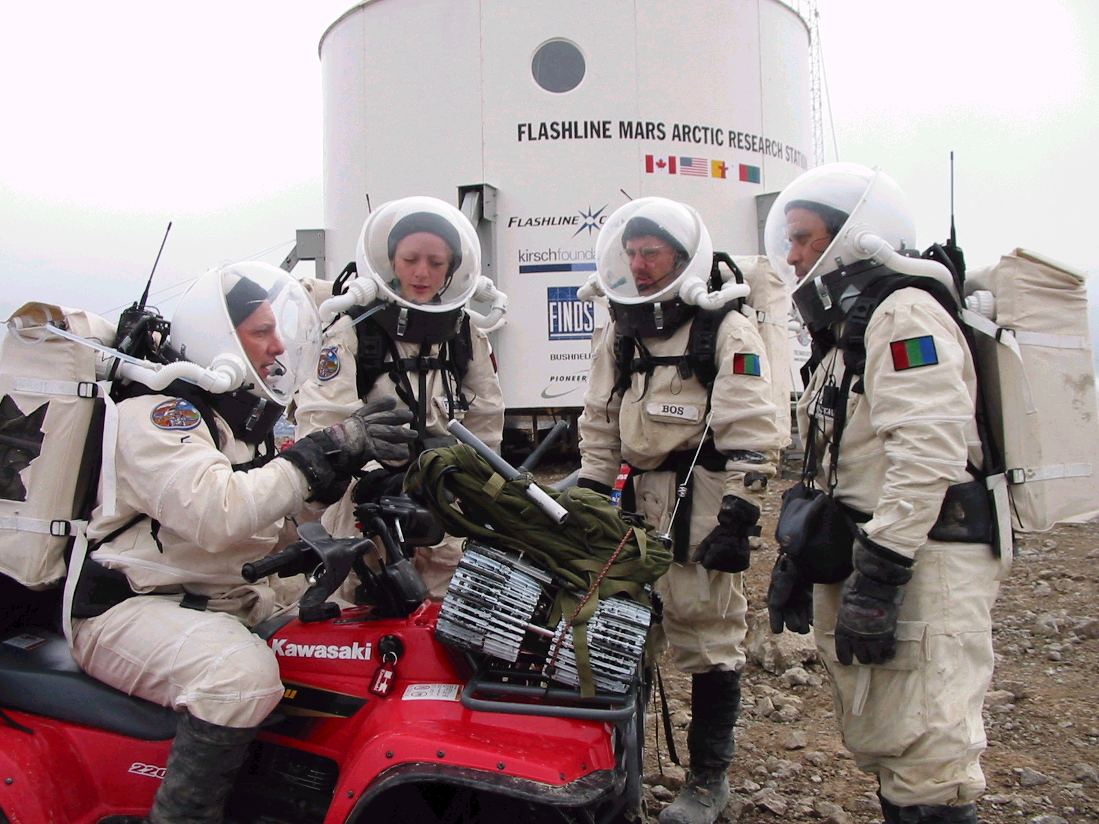

Before going to Mars, we need to study and solve likely issues and problems of life and work there. In 2000 The Mars Society built a $1 Million full-scale Martian habitat in a very Mars-like meteor crater in the Canadian Arctic (Flashline Mars Arctic Research Station). In 2002 we built another in Utah (Mars Desert Research Station). Here crews of scientists and engineers perform real work under simulated Mars conditions and protocols. Additional habitats are planned for Iceland and Australia. Crew reports are available at www.marssociety.org. The book Mars on Earth includes history, diaries, and early learnings.

MARS GRAVITY RESEARCH:

UNDERSTANDING IMPACTS ON PHYSIOLOGY

A major concern of exploration and settlement is the effect of Mars’ reduced gravity upon human life. Are the effects similar to or different from those of microgravity? To begin to answer this vital question, The Mars Society proposed a simulation study in orbit around Earth. Inspired by this concept, three universities -- MIT, the University of Washington, and the University of Queensland – teamed together to gather the required resources and to conduct the Mars Gravity Biosatellite mission. For more information, see the mission website, www.marsgravity.org/.

